**An impending crisis: Should we invest in renewables?**

What blood is for the human body, oil is for the world’s economy. Almost every country on earth is dependent on energy, which means that a lot of energy has to be produced. This image shows the energy consumption per person, per country.

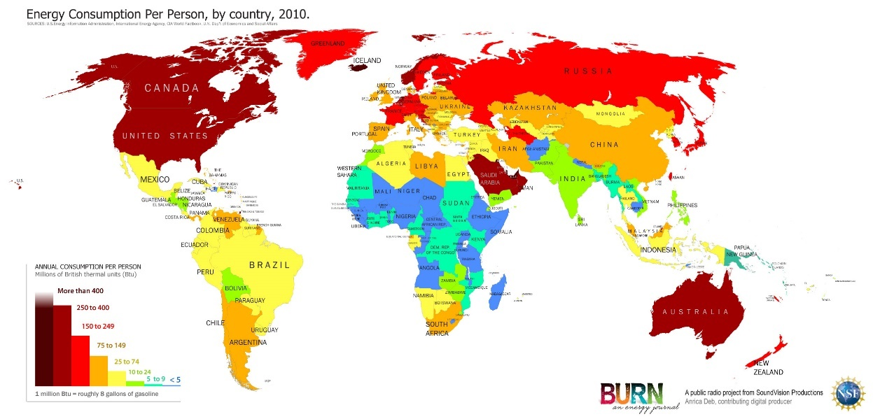

North vs. South – industrialized countries are using up the greater part of the planet`s energy resources.

**A planet fuelled by fossils …**

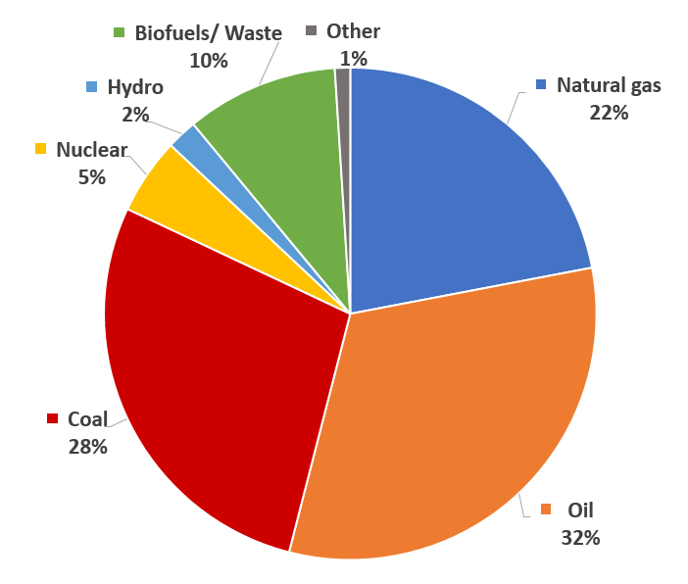On the left you can see which energy source accounts for how many percent of the total energy production. You can clearly see that oil, with 32%, makes up the largest portion, followed by coal and natural gas. Fossil energy represents 82% of total energy production, which is extremely much.

But why is that so? Fossil energy is a mature technology, which means that a technology has been used for long enough to exploit it efficiently. But there are two big problems with this form of energy production: fossil fuels are finite and burning them affects the climate. We all know that oil, brown coal and gas is created by dead animals and plants pressed under the earth crust. It takes a long, long time for the earth to make oil, gas and coal out of these raw materials, but we are using them faster than they can be re-produced. So, in some decades, there will be none of them left.

**… is heating up**

The other big problem is that when you burn fossils, a big amount of CO2 gets released into the air. CO2 is known as a greenhouse gas, which means that it affects the climate dramatically. Scientists are working on alternatives for fossil energy. Over the last 70 years, the annual medium temperature has risen by nearly 1 degree and the trend is continuing, if not speeding up.

**The 2°C target**To save our planet from a climate crisis that might threaten life on earth, 195 states signed the “Paris Agreement”. The aim of this agreement is to keep further temperature rise below plus two degrees. One of the measures discussed in Paris is the implementation of renewable energy technologies. These include hydropower, solar energy, wind energy and biomass – that would mean closing coal power plants rather than opening new ones as is happening around the world.

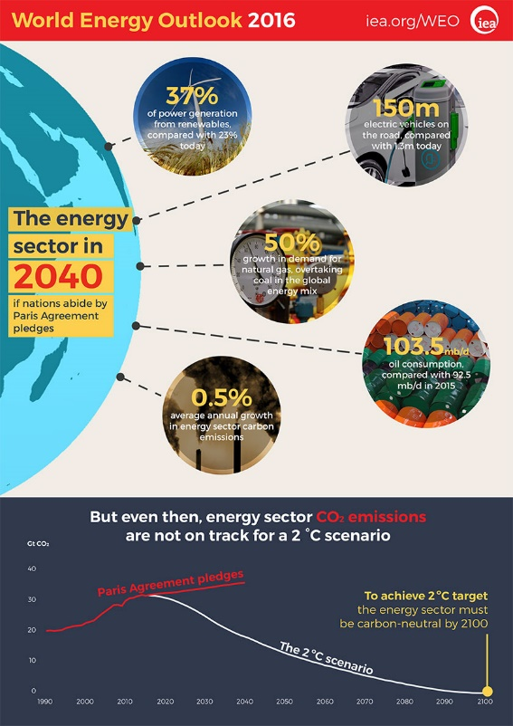**The world in 2040**

When millennials will reach their forties, they they will probably be driving electric vehicles and natural gas will overtake coal. However, experts from the International Energy Agency are not overly optimistic – CO2 emissions will still be too high keep temperature rise at +2.

**What can YOU do?**

Each of us can also help to stop climate change and use energy efficiently. Here are some examples:

* Use your bike, public transport or walk instead of going by car.
* Turn off unused lights and use the natural sunlight.
* Eat what you buy and do not waste food.
* Eat less meat; a plant based diet will contribute to using the planet`s resources wisely and efficiently.

**Be inspired and inspire others**

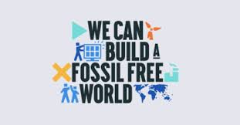

“If sunlight helps plants grow, imagine what your inner light can help flourish”, said Matshona Dhilwayo, a Canadian based Philosopher, Entrepreneur, and author of books such as *The Art of Wi*nning and *The Little Book of Inspir*ation. He is a regular contributor for The African Leadership Magazine, The CEO Magazine, among others. I think what he wants so say with that is that there is not a person out there who cannot help to make the world a better place.